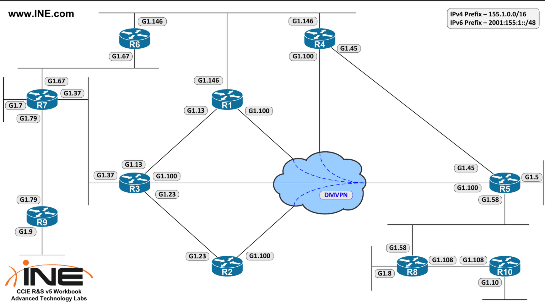

- Configure OSPF process id 1 on R6, R7, and R9
  - R6 & R7 : do not use any interface-level commands.
  - R6 : enable OSPF only for interfaces with exact IP of Lo0 and eth0/1.67.
  - R7 : enable OSPF on all interface with the subnets of Eth0/1.67 and Eth0/1.79.
  - R9 : Use only interface-level commands
  - Area 67 between R6 and R7, and Loopback0 of R6 and R7.
  - Area 79 between R7 and R9, and Loopback0 of R9.
  - Ensure R7 has connectivity with R6 and R9’s Loopback0.
  - Why R6 and R9 doesn’t receive any OSPF routes ?
  - Configure R7 so R6 and R9 receive inter area OSPF routes
- Configure OSPF process id 1 area 0 on R1, R2, R3, R4, and R5
  - advertise lo0 prefixes of R1 – R2 into area 0
  - advertise lo0 prefixes of R3 – R4 into area Y, Y is the router number
  - Use single network command on R5.
  - Use only interface-level on DMVPN spokes.
  - Change default OSPF network type to non-broadcast
  - Ensure IP connectivity between loopback0 prefixes of the routers

